

### 

##### Semester Two Examination, 2018

##### Question Paper

### ATAR ENGLISH

##### Year 12 Units 3&4

##### Time allowed for this paper

Reading time before commencing work: ten minutes

Working time for paper: three hours

##### Materials required/recommended for this paper

***To be provided by the supervisor***

This Question Paper

Standard Answer Book

***To be provided by the candidate***

Standard items: pens (blue/black preferred), pencils (including coloured), sharpener,

correction fluid/tape, eraser, ruler, highlighters

Special items: nil

##### Important note to candidates

No other items may be taken into the examination room. It is **your** responsibility to ensure that you do not have any unauthorised material. If you have any unauthorised material with you, hand it to the supervisor **before** reading any further.

##### Structure of this paper

|  |  |  |  |  |  |
| --- | --- | --- | --- | --- | --- |
| Section | Number of questions available | Number of questions to be answered | Suggested working time (minutes) | Marks available | Percentage of examination |
| Section One  Comprehending | 3 | 3 | 60 | 30 | 30 |
| Section Two  Responding | 6 | 1 | 60 | 40 | 40 |
| Section Three  Composing | 5 | 1 | 60 | 30 | 30 |
|  |  |  |  | **Total** | 100 |

##### Instructions to candidates

1. The rules for the conduct of examinations are detailed in the school handbook. Sitting this examination implies that you agree to abide by these rules.
2. Write your answers in the Standard Answer Book.
3. You must be careful to confine your answers to the specific question asked and to follow any instructions that are specified to a particular question.
4. You must not use texts from Section One to answer questions from Section Two.

Section One: Comprehending 30% (30 Marks)

In this section there are **three** texts and **three** questions. Answer **all** questions**.**

You are required to comprehend and analyse unseen written and visual texts and respond concisely in approximately 200–300 words for each question.

Suggested working time: 60 minutes.

Question 1 (10 marks)

Analyse the way narrative voice shapes suspense in Text 1.

**Text 1**

*An edited extract from the science fiction novel* The Day of the Triffids (1951) *by John Wyndham.*

What happened to Walter that fatal day, years later I do not know – though I can guess. I don’t think anybody really understands triffids, or ever will, but Walter came nearer than any man I have known. Or should I say he was given to intuitive feelings about them? It was a year or two after work began at the Arctic & European Fish Oil Co. – we were farming triffids on a large scale to extract their valuable oils and juices – that he first surprised me. We had knocked off for the day and were looking with satisfaction at fields of nearly fully grown triffids. They were arranged across the fields in rows tethered to sticks. We reckoned that in another month we’d be able to start tapping them for juice. The evening was peaceful; the only sounds, were the occasional rattling of the triffids’ stems against sticks. Walter regarded them with his head slightly tilted and removed his pipe. “They’re talkative tonight,” he observed.

I took that as anyone else would, metaphorically. “Maybe it’s the weather,” I suggested. “I fancy they do it more when its dry.”

He looked at me sidelong with a smile. “Do you talk more when its dry?”

“Why should –” I began, then noticed his expression. “You don’t really think they talk, do you?”

“Well, why not?”

“But it’s absurd. Plants talking!” I stared at them, and then back at him.

“You try thinking about it and watching them. I’d be interested to hear your conclusions,” he said. In all my dealings with triffids such a possibility had never occurred to me. But once he put the idea into my mind, it stuck. I couldn’t get away from the feeling that they might indeed be rattling out secret messages to one another.

Walter had become quite certain that they talked. “And that,” he argued, “means intelligence. It can’t be seated in a brain but that doesn’t prove there isn’t something there. There’s certainly intelligence, of a kind. Have you noticed that when they use their stingers to attack people they go for unprotected parts? Almost always the head but sometimes the hands. If you look at the statistics, the proportion of people stung in the eyes and blinded is remarkable – and significant.”

“Of what?” I asked.

“They know what they’re doing. We can see, and they can’t. Remove vision and our position becomes inferior because they have adapted to being sightless and we haven’t.”

“They can’t handle things. There’s very little muscular strength in that sting lash,” I pointed out. “True, but what’s the good of that if we can’t see? In fact, if it were a choice for survival between a triffid and a blind man, I know where I’d put my money on!”

“You’re assuming equal intelligence,” I said.

“Not at all. I don’t need to. I imagine it’s an altogether different type of intelligence, because their needs are simpler. I’m certain they could be dangerous. There they sit, with everyone thinking no more of them than they might of cabbages, yet half the time they’re pattering and clattering away at one another. Why? What is the patter about? That’s what I want to know.”

Question 2 (10 marks)

Evaluate the impact of Text 2 as an adaptation of Text 1 through its textual features.

**Text 2**

*This is a 1975 comic strip adaptation of the novel* The Day of the Triffids *by Gerry Conway & Rico*.

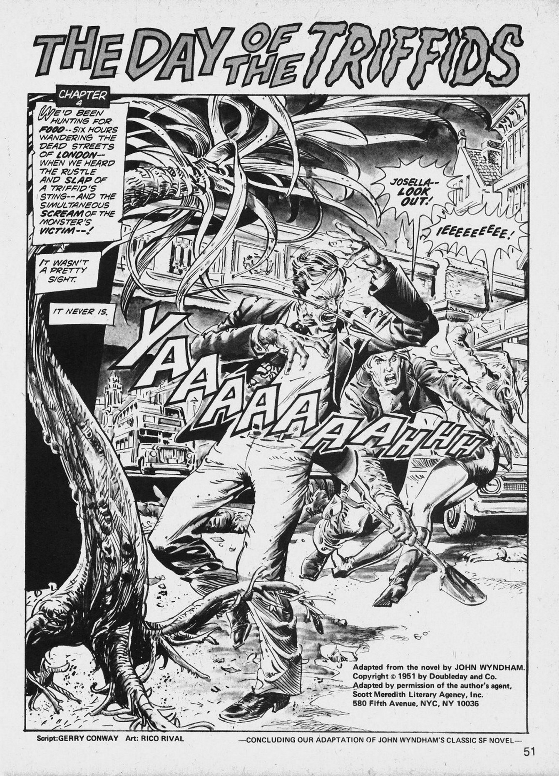

Question 3 (10 marks)

Explain how two techniques work to persuade the reader of plant intelligence in Text 3.

**Text 3**

*This edited extract is from an online feature article by American writer Ephrat Livni in 2018.*

Biologists believe that plants communicate by releasing chemicals via roots, branches, and leaves. They even sustain weaker members of their species by providing nutrients, which indicates a sense of kinship. Plants have preferences – their roots move toward water – and defence mechanisms. They have memories and can learn from experience. One 2014 experiment, for example, involved dropping potted plants called *Mimosa pudicas*. At first, they curled their leaves defensively. But when they learned no harm would come to them, they stopped protecting themselves. Does any of this qualify as consciousness? Danny Chamovitz, director of Plant Biosciences at Tel Aviv University, says that plants are neither conscious nor intelligent, though they are incredibly complex. Plant awareness shouldn’t be confused with our human experience of existence he says. “All organisms have to find a way to survive. It’s not unique to people. Are plants self-aware? No. We care about plants but do plants care about us? No.” The thing is, Chamovitz can’t prove that plants don’t care about us. We know that hugging trees, literally, has a medicinal effect. But we can’t test whether plants love us back or feel good when we care for them. Michael Marder, the author of *Plant Thinking* says we underestimate plants. “Plants make complex decisions, like when to bloom. If consciousness is ‘having knowledge’ then plants fit the bill.”

We believe that our experience of life is what defines consciousness, and that our brain’s processes are the height of intelligence. But there is plenty of evidence that other modes of existence have arguably intelligent or conscious experiences. Evolutionary ecologist Monica Gagliano insists that plants are intelligent. Her experiments suggest that – while plants don’t have a brain – they behave like intelligent beings. She says that if plants can summon knowledge about experiences then plants are clearly able to remember and learn. “The realisation for me isn’t that plants must be something more than we give them credit for, but what if everything around us – animal, plant, bacteria, or whatever, is also?” Acknowledging plant intelligence could put us in an awkward position. Perhaps there is nothing we can eat that isn’t some form of murder – not even a salad! Expanding definitions of intelligence could mean admitting we’ve limited our worldview altogether. What if everything is intelligent in its own way, and we’re just not smart enough to see it?

**End of Section One**

**This page has been left blank intentionally**

**Section Two: Responding 40% (40 Marks)**

In this section there are **six** questions. Answer **one** question.

Your response should demonstrate your analytical and critical thinking skills with reference to  
any text or text type you have studied.

Suggested working time: 60 minutes.

Question 4 (40 marks)

Discuss how ideas and values in at least **one** text continue to be relevant for different audiences.

Question 5 (40 marks)

Consider how at least **one** text conforms to a genre's characteristics or disrupts that expectation.

Question 6 (40 marks)

Discuss how patterns of repetition contribute to meaning and stylistic effect in at least **one** text.

Question 7 (40 marks)

Examine how at least **one** text represents ideas of a changing society or world for an intended audience.

Question 8 (40 marks)

Compare how **two** texts use voice to communicate ideas about vulnerable individuals or groups and position empathy.

Question 9 (40 marks)

Consider how your response to controversy in at least **one** text relates to a contemporary and cultural context.

**End of Section Two**

**This page has been left blank intentionally**

**Section Three: Composing 30% (30 marks)**

In this section there are **five** questions. Answer **one** question.

You are required to demonstrate writing skills by choosing a form of writing appropriate to a specific audience, context and purpose.

Suggested working time: 60 minutes.

Question 10 (30 marks)

There are the moments that change us and moments that define who we are.

In a form of your choice explore this statement through a distinct voice and style.

Question 11 (30 marks)

Compose a text that uses language features and techniques to persuade an Australian audience to: ‘Donate. Don’t dump.’

Question 12 (30 marks)

Inspired by this Anzac Day image write a text that interprets the value of remembrance in a modern world.

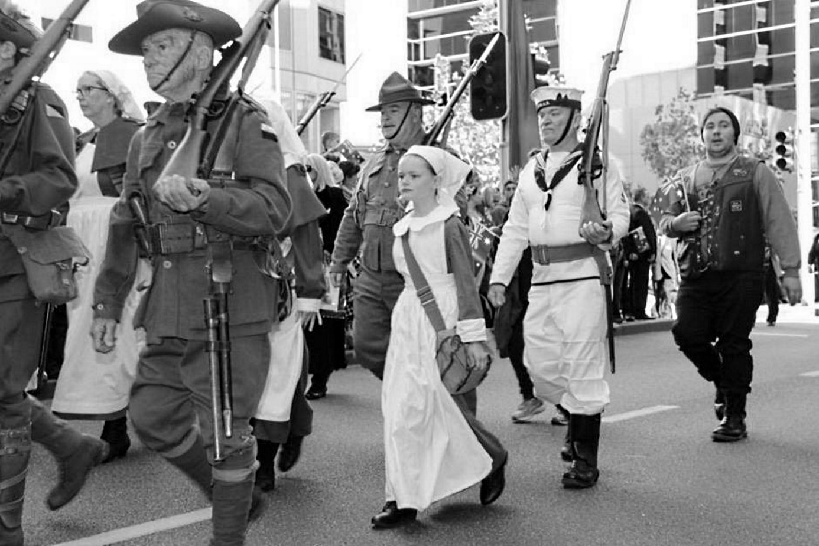

Question 13 (30 marks)

"Nothing adds interest and complexity to a community like diversity." Bernard Salt.

In a form of your choice use this quote to position response to its central idea.

Question 14 (30 marks)

Create a text that imagines the chance encounter suggested below through a particular point of view.

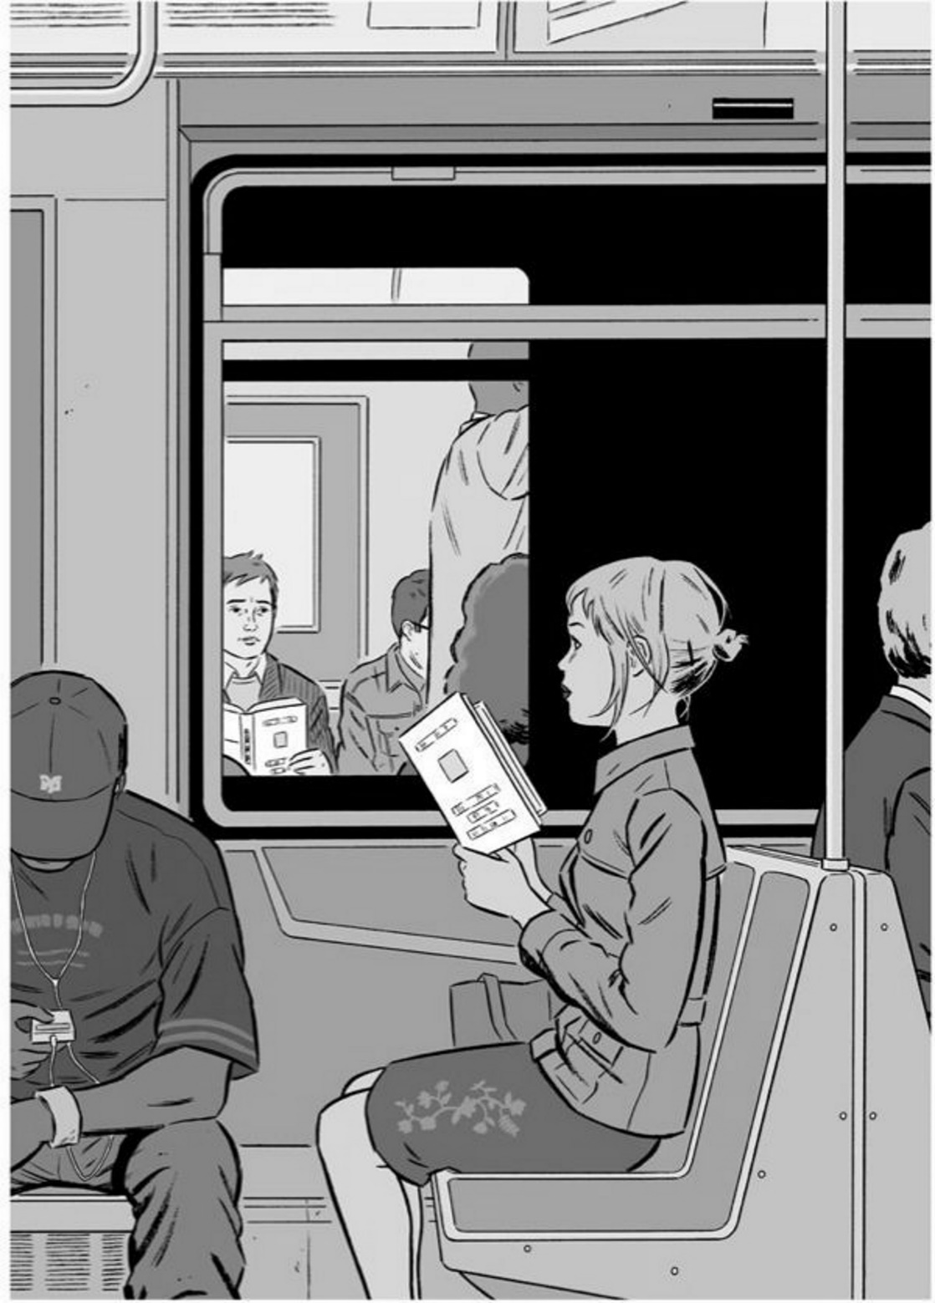

**ACKNOWLEDGEMENTS**

**Text 1** Wyndham, J. Edited extract from novel *The Day of the Triffids* Publisher: Doubleday(1951).

**Text 2** Conway, G and Rico: Reproduction of illustration from *Rival Unknown Worlds of* *Science Fiction* (1975) adaptation of novel The Day of the Triffids. Publisher: Scott Meredith Literary Agency, New York.

**Text 3** Livni, E**.** Edited extract is from article *A debate over plant consciousness is* *forcing us to confront the limitations of the human mind.* Publisher: Quartz online magazine (2018).

**Question 12** Black and white reproduction of image sourced from ABC News, WA Anzac Day 2015 in pictures.

**Question 14** Tomine, A. Reproduction of illustration *Missed Encounter.*

© 2018 WA Exam Papers. Leeming Senior High School has a non-exclusive licence to copy and communicate this document for non-commercial, educational use within the school. No other copying, communication or use is permitted without the express written permission of WA Exam Papers. SN056-739-1.